Exploring the Beauty of Michigan:
Chapel Rock
4/22/2021

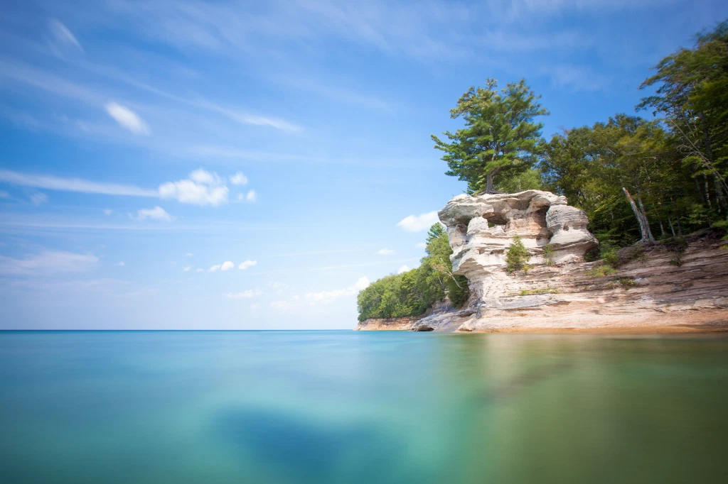

Photo Taken by Rudy Malmquist
Retrieved from: Farlane, & Michigan in Pictures. (2016, August 18). Chapel Rock. Retrieved April 22, 2021, from https://michpics.wordpress.com/tag/chapel-rock/
Jozie Pinkowski
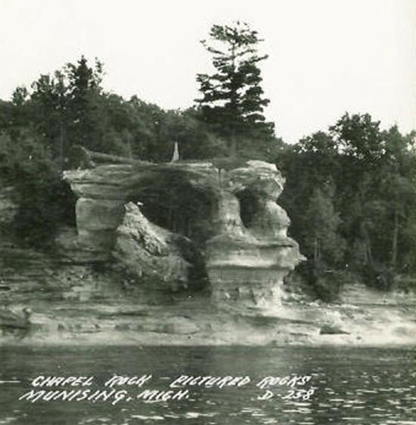
On the shores of Lake Superior, the beautiful configuration of Cambrian-Age sandstone displays a natural rock formation that was carved out by the high waters of Lake Nipissing, nearly 3,800 years ago. Located within the Pictured Rocks National Lakeshore, fifteen miles east of Munising, Michigan, the formation known as Chapel Rock has greatly changed over the past few decades, even centuries. The color of the rock is somewhat of an ombre from warm orange tones at its base due to mineral concentration, to a lighter tan or beige color near the top. The natural archway connecting the rock formation to the mainland collapsed in the 1940s, leaving a disconnected tower of sandstone on the shore. On top of Chapel Rock lives an approximately 250-year-old white pine tree, commonly known as the “lone pine”, or “lone white pine”. The tree, while seemingly should be disconnected from the mainland source, is actually still connected through its century old root system. Since the collapse of the arch, the root system has contained so much strength that the majority of it remains exposed from the rock and intact to the mainland without any supports in place, and the cliff edge is protected by order of the Lakeshore Superintended that no one shall climb the formation.
This photo of Chapel Rock, prior to the archway collapse in 1940s. Captured in the mid-1900s, this image is courtesy of the National Park Service. Retrieved from: The History of Pictured Rocks in Photos. (2021, January 14). Retrieved April 22, 2021, from https://picturedrocks.com/our-stories/the-history-of-pictured-rocks-in-photos/
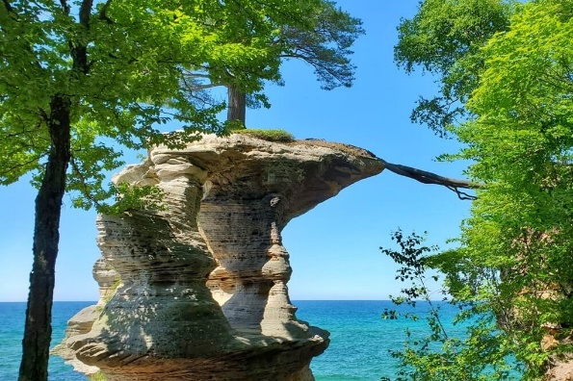
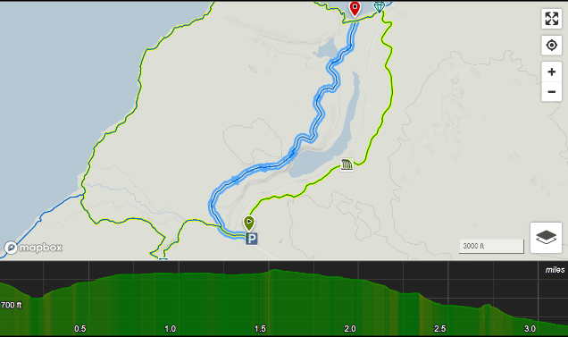
There are two main ways to visit Chapel Rock, but one of them requires more of a physical commitment than the other. One option is to embark on a Pictured Rocks Boat Tour, which is generally anywhere between two to three hours long, approximately 40 miles per trip. This all depends on water conditions, wind speed, and how many passengers the boat is carrying, which differs day to day. Although the duration of the tour seems extensive, the boat takes passengers along the whole Pictured Rock National Lakeshore, which means the whole cruise is not just for one rock formation. It is to see multiple wonders of Michigan’s northern shorelines and natural environment, including narrations of histories and fun facts about each formation throughout the tour. The other option is to hike one of the various trails in the area, allowing a closer look compared to the boat tour. There are less physically demanding trails ranging from 2.5 to 3.5 miles, starting at the trailhead near the closest parking lot to Chapel Rock. There are also trails around 10.4 to 10.6 miles distance that, which allow hikers to experience more of the natural environment like Mosquito Falls and more of the shoreline, but also call for that higher demand of physical commitment.
This photo showing the exposure of the lone pine’s root system since the collapse of the arch. Retrieved from: Hike to chapel rock: Where to see a tree growing on a rock IN Pictured ROCKS 🌳 up MICHIGAN travel blog. (2021, March 14). Retrieved April 22, 2021, from https://www.flashpackingamerica.com/michigan-travel/chapel-rock-hike-pictured-rocks/
This screen capture shows the highlighted path of the Chapel Lake Trail, estimated at 3.2 miles distance. It also shows the changes in elevation as the hike goes along. Retrieved from: Chapel Lake Trail Hiking Trail, Munising, Michigan. (n.d.). Retrieved April 22, 2021, from https://www.hikingproject.com/trail/7021152/chapel-lake-trail
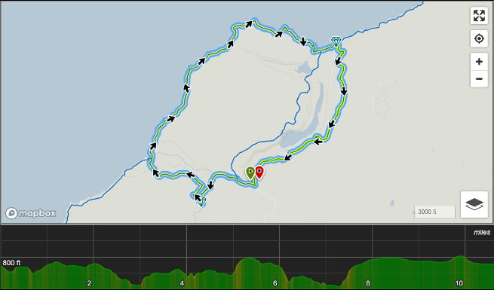
The 10.4-to-10.6-mile hike is the perimeter of what is known as the Chapel Basin Loop. Taking this hike without any shortcuts would allow for exploring the natural scenery, which has five waterfalls, two beaches, and two campgrounds for overnight stay or meal breaks, various rock formations along the shore and a splendid view overlooking Lake Superior. If there is a will to do so, there is also a 42.4-mile hike from Grand Marais to Munising, Michigan, known as the Lakeshore Trail, which is part of the greater North Country National Scenic Trail. On average, the excursion takes between four and five days to complete, around nine to twelve miles per day, and is a test of physical endurance. Hikers would pass sandstone cliffs, lighthouses, shipwrecks, and huge mounds of sand dunes along the way.
This screen capture shows the highlighted path of the Chapel Basin Loop, estimated between 10.4 to 10.6 miles distance. It also shows the changes in elevation as the hike goes along. Retrieved from: Chapel Loop Hiking Trail, Munising, Michigan. (n.d.). Retrieved April 22, 2021, from https://www.hikingproject.com/trail/7019624/chapel-loop

While the natural scenery of Chapel Rock is breathtaking, the history behind it is even more captivating. In 2018, the Pictured Rocks National Lakeshore of Michigan became the first national site commemorated on a United States quarter. Before the coin was released into the coin circulation on February 5, 2018, there was a selection process for what image would be placed on the quarter. Through a selective process between partnership of the U.S. Mint program and representatives of the national site, thirteen designs were in the running and once passed and reviewed by the Commission of Fine Arts and the Citizens Coinage Advisory Committee, the Treasury Secretary chose the winner. An image of Chapel Rock, post-arch collapse, with the lone white pine on the top, outlooking Lake Superior, was created by Paul C. Balan and sculpted by Michael Gaudioso.
The intricacy of details in this coin truly represents the natural beauty of Michigan’s shoreline, but also depicts the importance of preserving national parks and what is in them, as well as how to be aware of safety when visiting and following the rules and laws that protect visitors, wildlife, and the environment. That includes maintaining clean environments in man-made sites like campgrounds and along the trails, as well as caution around the different species that inhabit the interior of the Chapel Basin Loop, like bears and types of small, biting insects. Also, being on the lookout for poison ivy, as well as falling trees or branches would be a safe choice, too.
This photo shows the U.S. Mint image of the reverse or tails side of a 2018 Pictured Rocks National Lakeshore Quarter for Michigan, created by Paul C. Balan and sculpted by Michael Gaudioso. Retrieved from: Pictured Rocks National Lakeshore Quarter. (2017, December 14). Retrieved April 22, 2021, from http://www.parkquarters.com/pictured-rocks-national-lakeshore-quarter#:~:text=Pictured%20Rocks%20National%20Lakeshore%20of,a%20U.S.%20quarter%20for%202018.&text=The%20coin%20represents%20the%20forty,runs%20from%202010%20to%202021.
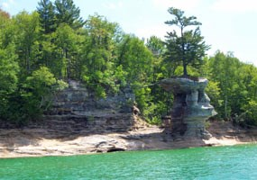
Over the past six decades since the collapse of the archway, there likely has been a change in the natural environment, slowly but surely. Something as dramatic as the collapse gives a clear visual of the changes that can occur, but studying the erosion patterns of the soft Cambrian-Age sandstone may be able to help researchers estimate what types of changes are possible in the future. Continue to explore the beauty of Michigan, and in the words of Albert Einstein, “Look deep into nature, and then you will understand everything better.”
This photo shows a more recent representation of what Chapel Rock looks like today. Retrieved from: Scenic Sites. (n.d.). Retrieved April 22, 2021, from https://www.nps.gov/piro/planyourvisit/scenicsites.htm
References:
Chapel Lake Trail Hiking Trail, Munising, Michigan. (n.d.). Retrieved April 22, 2021, from https://www.hikingproject.com/trail/7021152/chapel-lake-trail
Chapel Loop Hiking Trail, Munising, Michigan. (n.d.). Retrieved April 22, 2021, from https://www.hikingproject.com/trail/7019624/chapel-loop
Chapel rock. (2019, March 27). Retrieved April 22, 2021, from https://www.atlasobscura.com/places/chapel-rock
Chapel Rock. (n.d.). Retrieved April 22, 2021, from https://upper-michigan.com/chapel-rock/#:~:text=Chapel%20Rock%20is%20located%20along,the%20end%20of%20Chapel%20Road.
Farlane, & Michigan in Pictures. (2016, August 18). Chapel Rock. Retrieved April 22, 2021, from https://michpics.wordpress.com/tag/chapel-rock/
Hike to chapel rock: Where to see a tree growing on a rock IN Pictured ROCKS 🌳 up MICHIGAN travel blog. (2021, March 14). Retrieved April 22, 2021, from https://www.flashpackingamerica.com/michigan-travel/chapel-rock-hike-pictured-rocks/
Hiking Trail - Chapel Basin - U.P. Trails. (n.d.). Retrieved April 22, 2021, from https://www.gobigsmile.com/applications/uptrails/ChapelBasin.cfm
The History of Pictured Rocks in Photos. (2021, January 14). Retrieved April 22, 2021, from https://picturedrocks.com/our-stories/the-history-of-pictured-rocks-in-photos/
Murphy, P. (2019, March 06). "When Albert Einstein said 'look deep into nature, and then you will understand everything better'... Retrieved April 22, 2021, from https://medium.com/@paulaustinmurphy2000/when-albert-einstein-said-look-deep-into-nature-and-then-you-will-understand-everything-better-9b45db4dbf06
Pictured Rocks - Chapel Basin Loop. (n.d.). Retrieved April 22, 2021, from https://www.michigantrailmaps.com/member-detail/pictured-rocks-chapel-basin-loop/
Pictured rocks Cruise. (n.d.). Retrieved April 22, 2021, from https://www.nps.gov/piro/planyourvisit/boat-tour.htm
Pictured Rocks National Lakeshore Quarter. (2017, December 14). Retrieved April 22, 2021, from http://www.parkquarters.com/pictured-rocks-national-lakeshore-quarter#:~:text=Pictured%20Rocks%20National%20Lakeshore%20of,a%20U.S.%20quarter%20for%202018.&text=The%20coin%20represents%20the%20forty,runs%20from%202010%20to%202021.
Pictured Rocks National Lakeshore Quarter. (2017, December 14). Retrieved April 22, 2021, from http://www.parkquarters.com/pictured-rocks-national-lakeshore-quarter#:~:text=Pictured%20Rocks%20National%20Lakeshore%20of,a%20U.S.%20quarter%20for%202018.&text=The%20coin%20represents%20the%20forty,runs%20from%202010%20to%202021.
Pictured rocks: Lakeshore trail. (n.d.). Retrieved April 22, 2021, from https://www.michigantrailmaps.com/member-detail/pictured-rocks-lakeshore-trail/
Safety. (n.d.). Retrieved April 22, 2021, from https://www.nps.gov/piro/planyourvisit/safety.htm
Scenic Sites. (n.d.). Retrieved April 22, 2021, from https://www.nps.gov/piro/planyourvisit/scenicsites.htm
Unser, M. (2016, July 08). 2018 Quarter and 5 Oz Coin Design Candidates. Retrieved April 22, 2021, from https://www.coinnews.net/2016/07/08/2018-quarter-and-5-oz-coin-design-candidates/

